Prompts for Activity 2 – The Koch Curve

Question 1: If the original line has length 1, how long are the following curves, which form the first few steps of creating the Koch curve?
Hint: At each step, remember that the new line segments are one-third the length of the previous line segments.
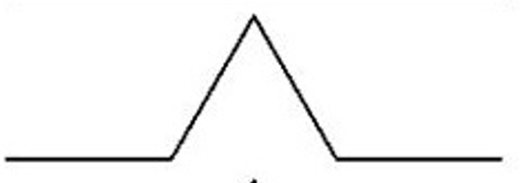
Length: _________________________

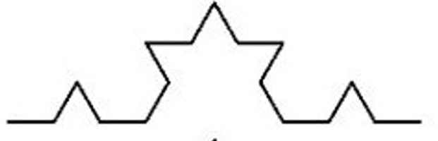

Length: _________________________

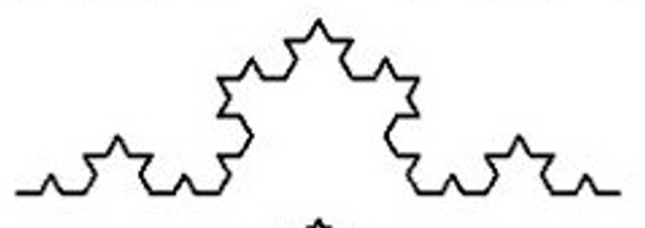

Length: _________________________

Question 2: Find a general formula for the length at the N^{th} step. (You just found the lengths for N=1, 2, 3.)

